Mistakes Most Buyers Make

- Making an offer prior to being pre-qualified for a mortgage.
  - You will know what you can afford and what price range you should be looking at.
- Limiting searches to open houses, ads or internet
  - Many houses have been sold by the time they are on the internet or in ads. Best action is to contact a realtor.
- Not having a home inspection
  - Trying to save money now can cost you plenty in the long run.
- Choosing a real estate agent who is not committed to forming a strong business relationship with you.
  - Choose a professional who is dedicated to serving your needs. Remember the realtor works for you.
- Thinking there is only one perfect house for you.
  - Ask you realtor for a CMA. This compares similar homes that have recently sold or are still for sale. Then you can compare.
- Not considering long term needs.
  - Where are you in your stage of life?
- Not knowing total costs involved.
  - Closing costs, lawyer fees, taxes, adjustments, title insurance etc.
- Not Following through on due diligence
  - Buyers should make a list of concerns and items that are important to them, such as; schools, power lines future developments, environmental issues, proximity to your work and make sure you get the answers to these questions before proceeding.

This information is provided to assist in your home purchase by
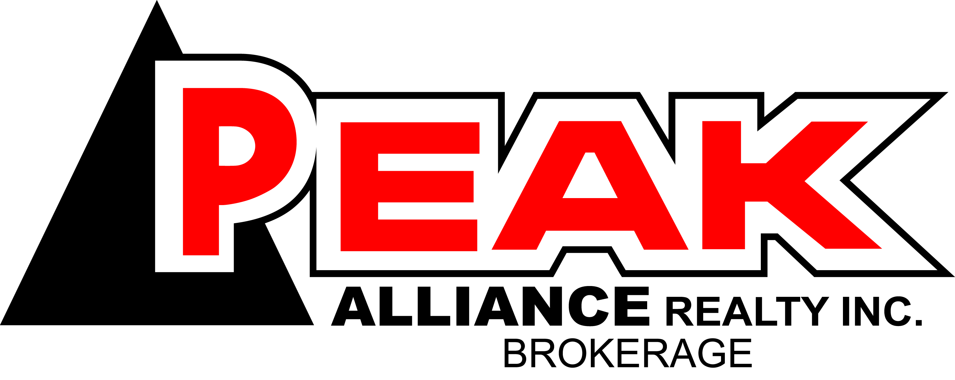
325 West Street Bldg B Unit 103
Brantford Ontario, N3R 3V6
Office: 519 752-3500

